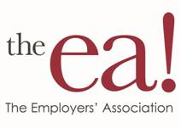

HR Consultant

The Employers’ Association is a not for profit organization that provides HR Services to over 600 member companies in the Northwest Ohio and Southeast Michigan area. We are seeking a full-time HR Consultant to assist in the growing HR consulting business at the EA. The selected candidate will be responsible for updating employee handbooks, conducting compliance training, designing compensation plans, writing job descriptions, conducting HR audits, assisting members calling the HR Hotline, providing temporary HR support to members and other projects.

Ideal candidates will have an HR generalist background with 5-7 years of experience, a Bachelor’s degree in HR or the equivalent in experience, and HR Certification (PHR, SPHR, SHRM-CP, or SHRM-SCP). In addition, demonstrated customer service, communication, and PC skills are required.

We offer a competitive salary, flexible hours, and a great working environment.

If you meet the requirements, please e-mail a resume’ with salary requirements to:

Bob Bethel, SPHR, SHRM-SCP
VP of HR and Learning Services
The Employers’ Association
1787 Indian Wood Circle, Suite A
Maumee, OH 43537
Bob.bethel@theea.org

